**Module 3 - Linux Commands**

Basic linux [operations](https://youtu.be/sWbUDq4S6Y8?t=8659)

**LS Command** - Lists all the files and folders in a directory

**CD Command** - changes the directory

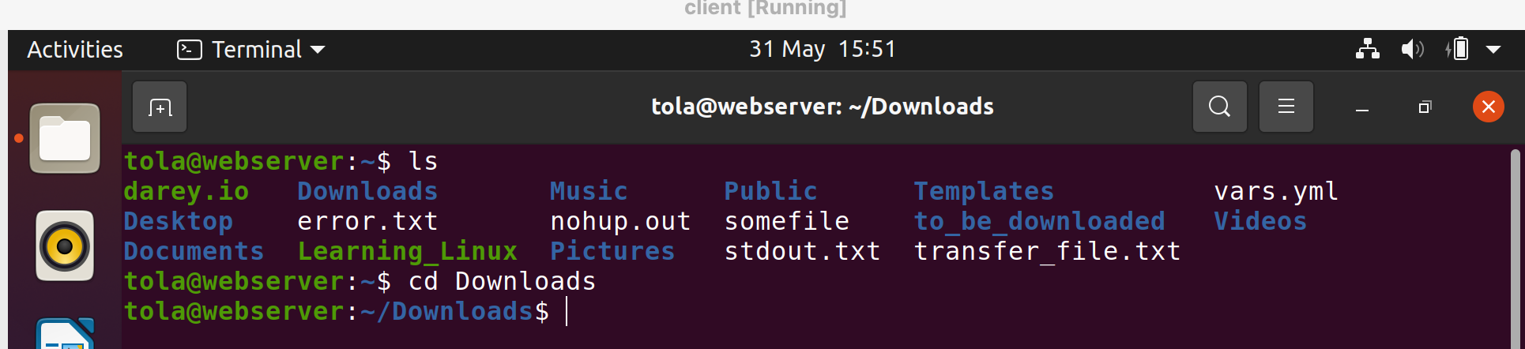

**MKDIR Command** - Creates a new directory

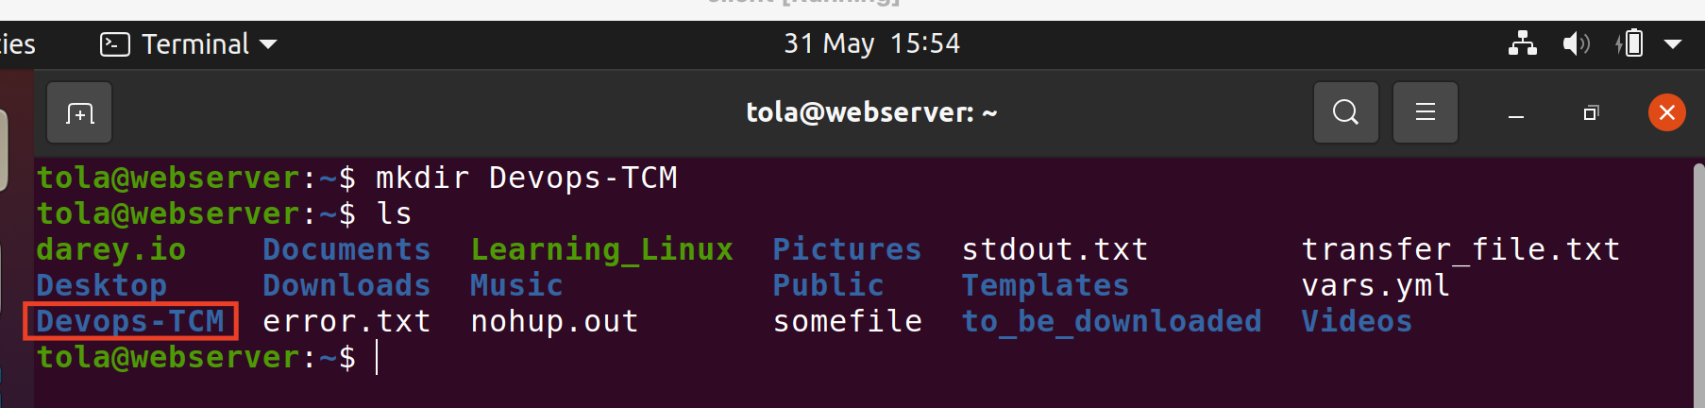

**TOUCH Command** - Creates a new file

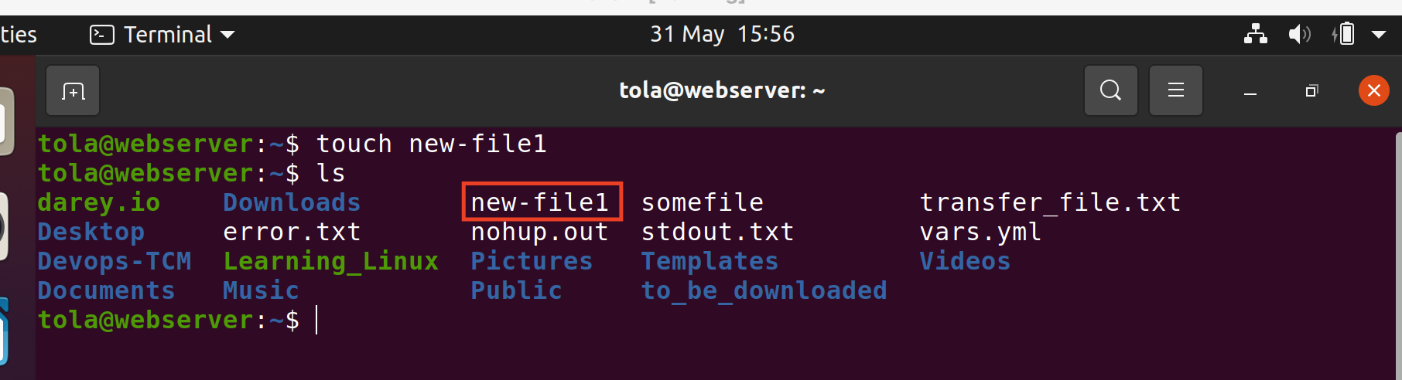

**CAT Command** - Opens/displays the content of a file

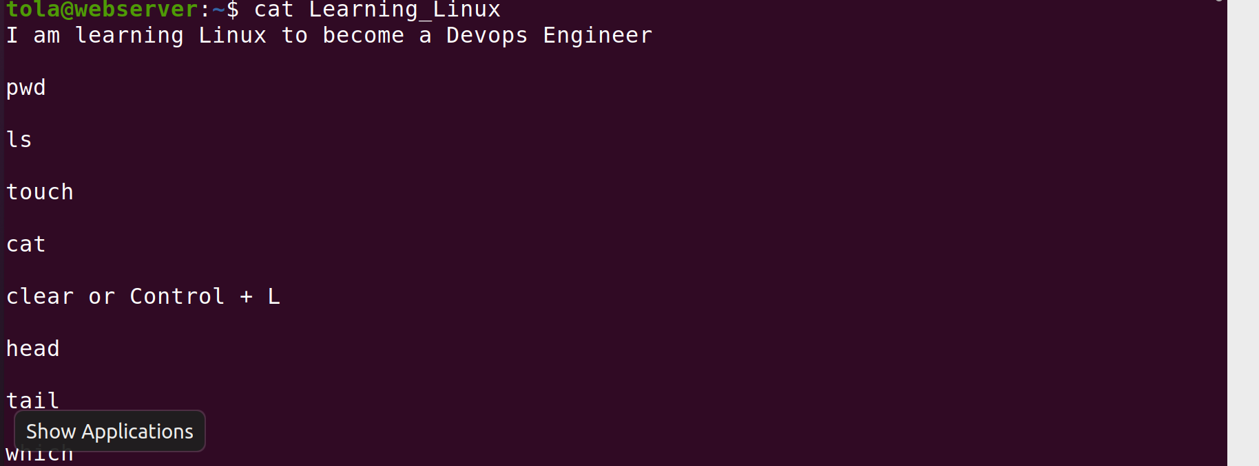

**CP Command**

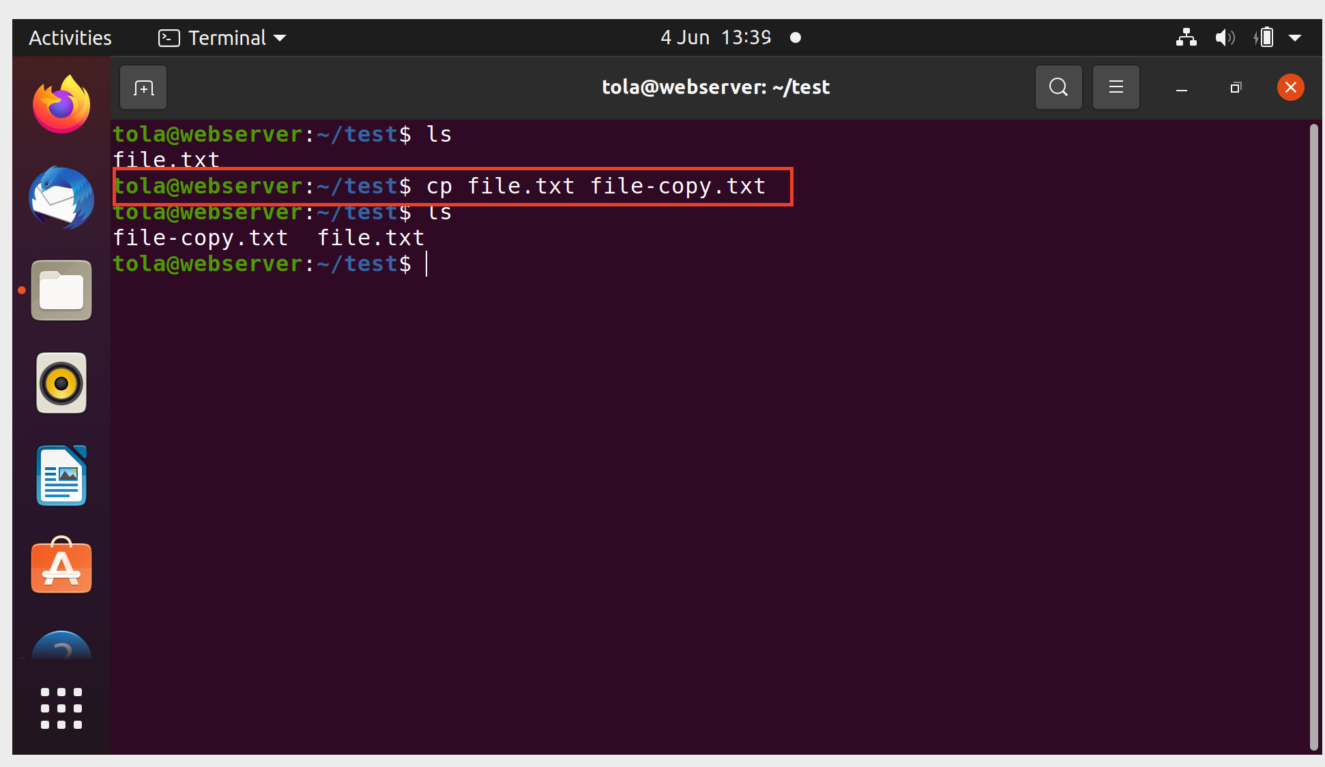

Note that cp -r [source-file-parameter] [destination-file-parameter] can be used to recursively copy all the files in a folder to another destination when used with the ‘-r’ option

**MV Command** - This can be used to change the name of a file as well as the destination of the file

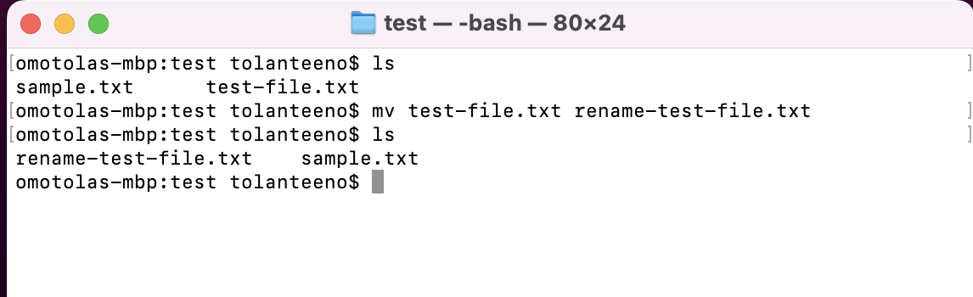

**SED command** - Streamline editor that allows you to edit files with commands with no need to text editor

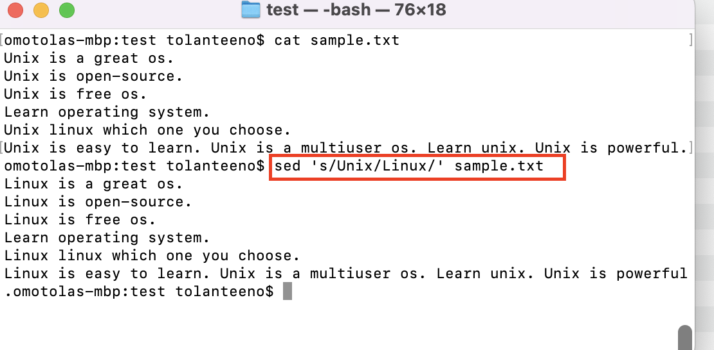

In the highlighted text above, the (‘s) substitute option has been used to replace all instances of ‘Unix’ with ‘Linux’ in the sample.txt file. Note that the changes only occur for the first occurrence of ‘Linux’ on a line.

If you want the changes to occur for the second occurrence of Linux, use the command below:

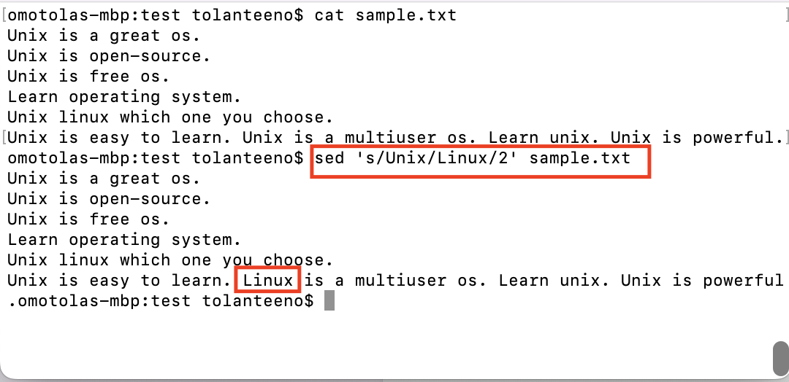

If you want the changes to happen globally, use the command below:

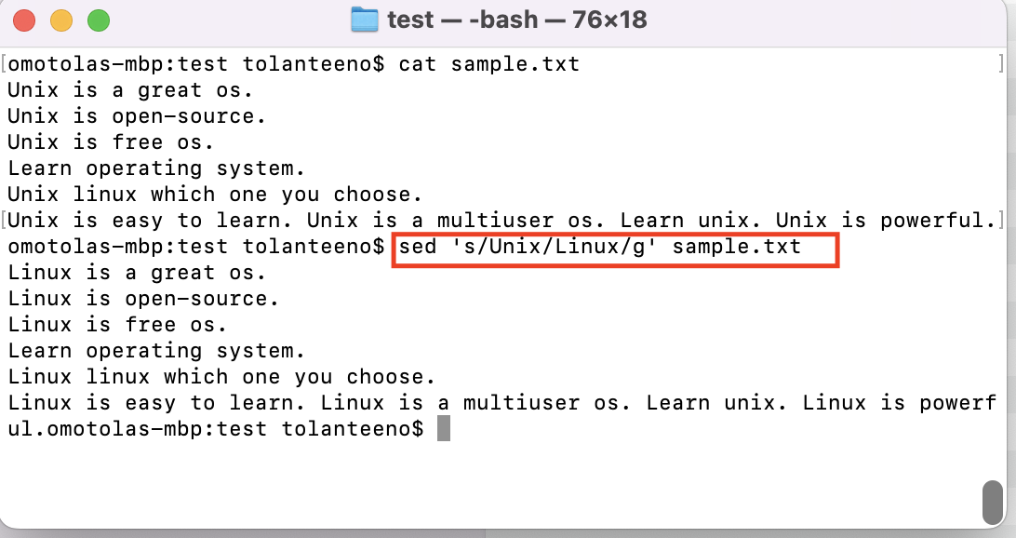

**GREP Command** - Global regular expressions

This is used to search text or searches the given file for lines containing a match to the given strings or words

syntax : grep <options> <pattern> <file>

The example below uses the grep command to search for ‘Apple’ in the fruits.txt file. Note that the pattern can be case sensitive

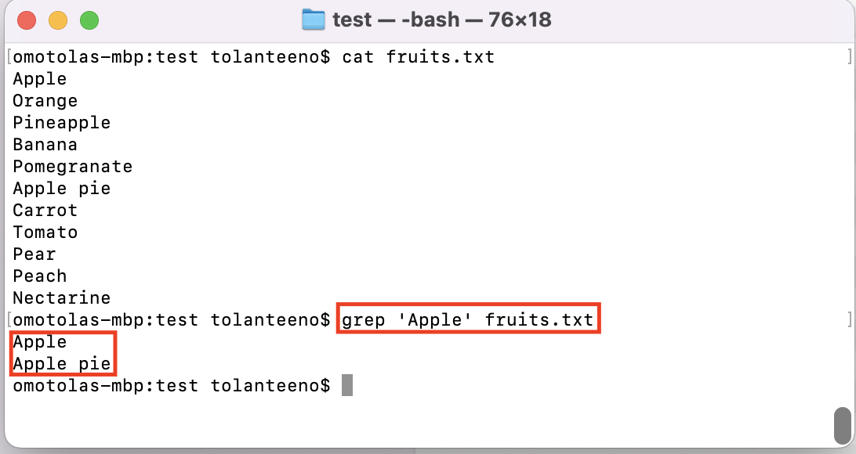

Another way of using grep is in combination with the processes command ‘ps’ whereby the command below is used for search for running processing with ‘bash’.. The command and results are shown below:

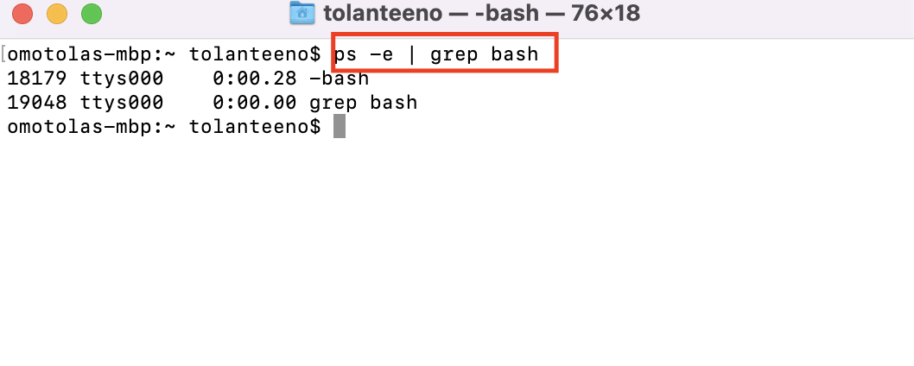

**CUT Command** - This is used to cut out sections from each line of files and writing the result to a standard output. Range of bytes can be specified using ‘-’ You must specify list of byte numbers otherwise you will get an error

Syntax: cut [option] [file]

The example below is used to cut out a list without ranges:

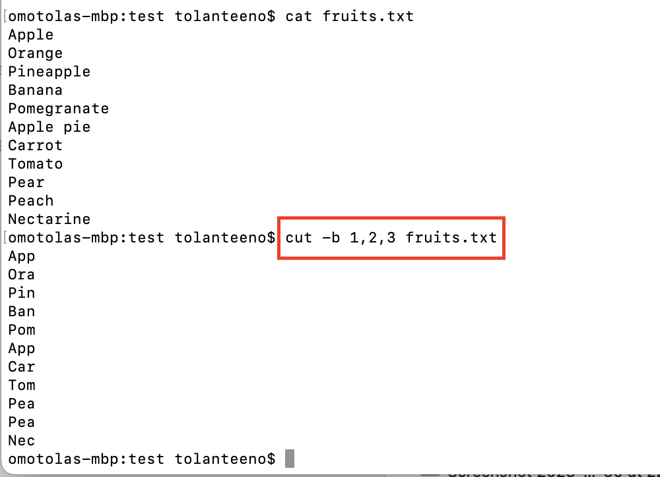

The next example below is used to cut out a list with ranges

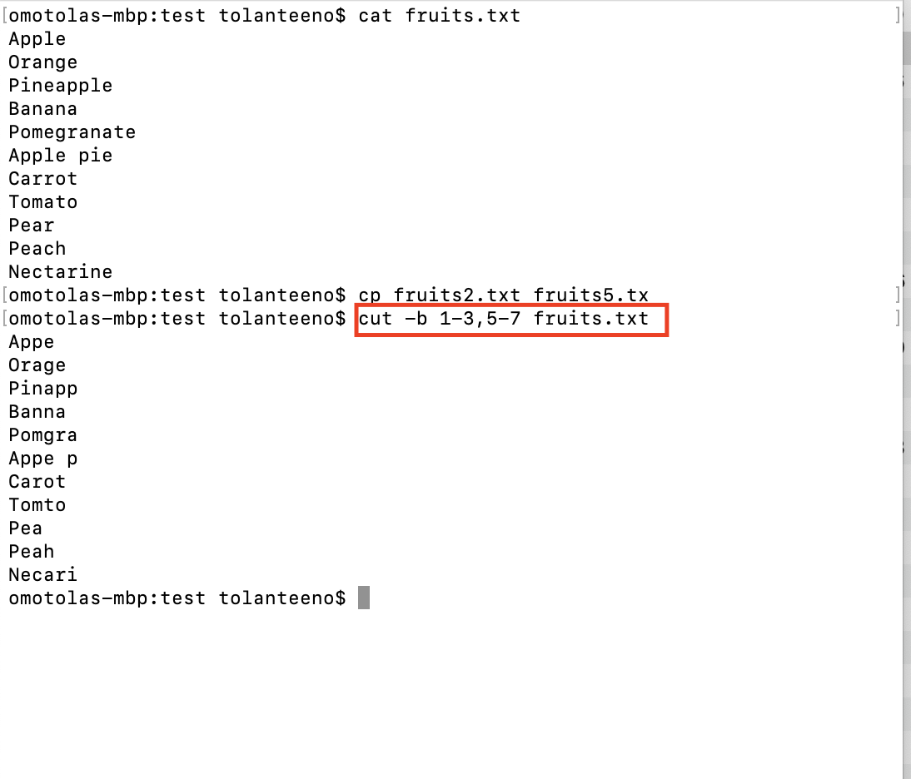

The ‘-c’ option is used to cut by character. This selects the character given to option ‘-c’

The next two snapshots shows two scenarios where certain bytes are cut out of the list and also shows when a range of bytes are cut out fo the list using -c option:

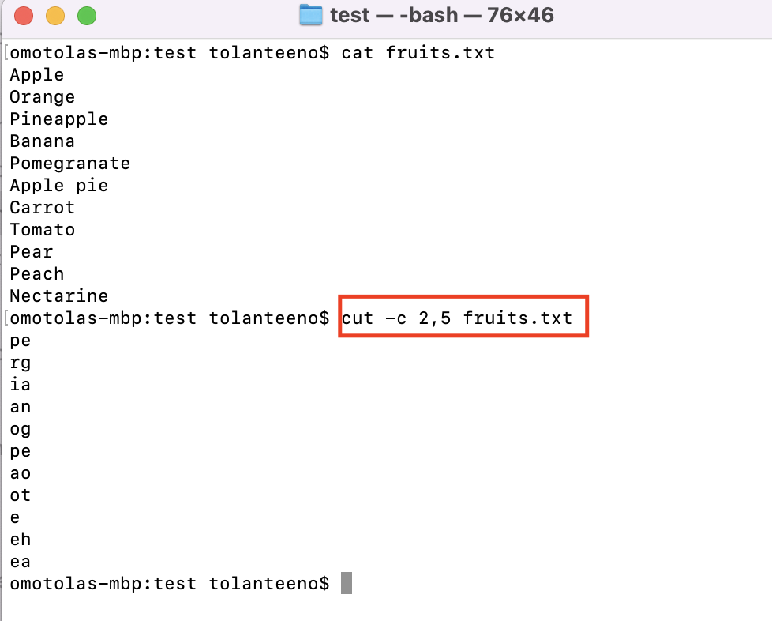

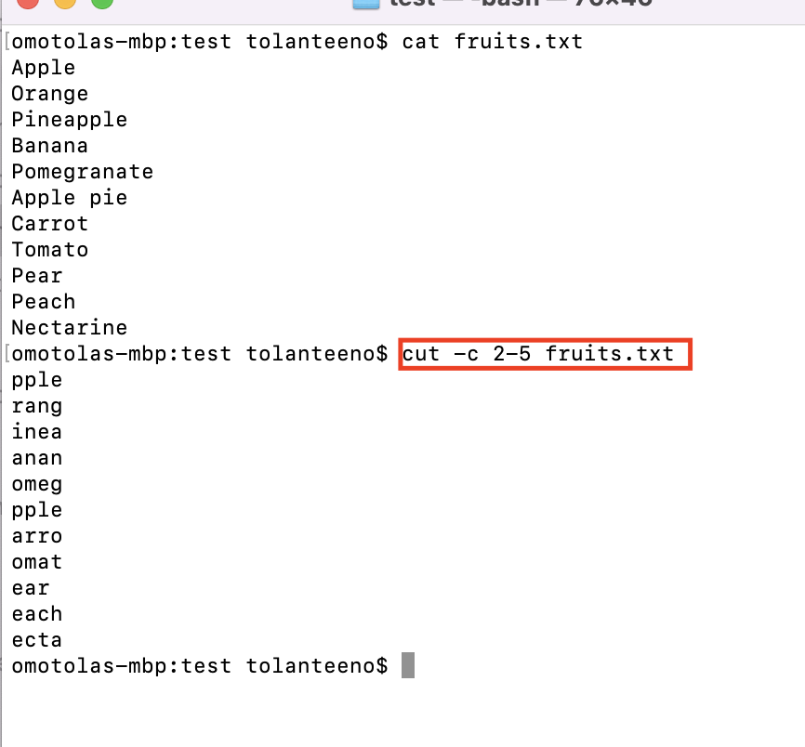

Using cut -f

Syntax: cut -d “delimiter” -f “field-number” file

In this example below, i want to cut out the first column so I have specified the delimiter as a space “ “ and the first field has be selected which gives the result in the snapshot below

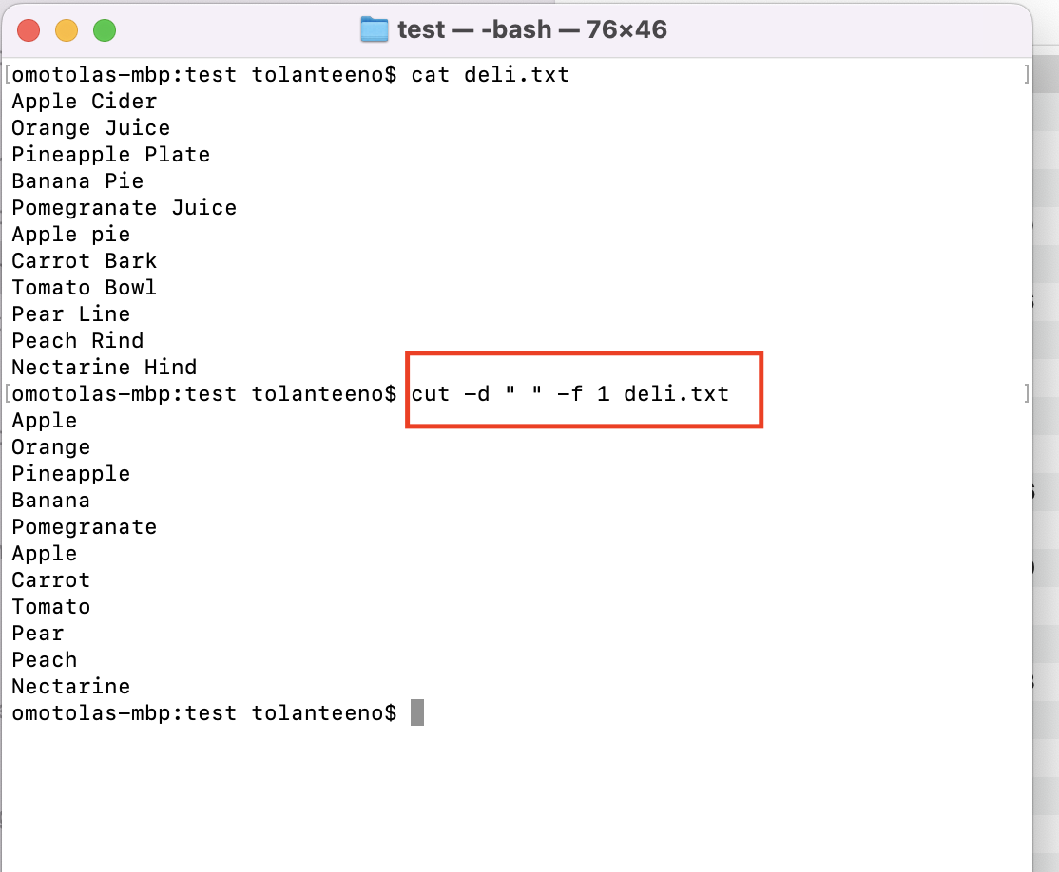

In the next example, the output of the ls -l command acts as input to the cut command and we get only the first field of the ls -l command

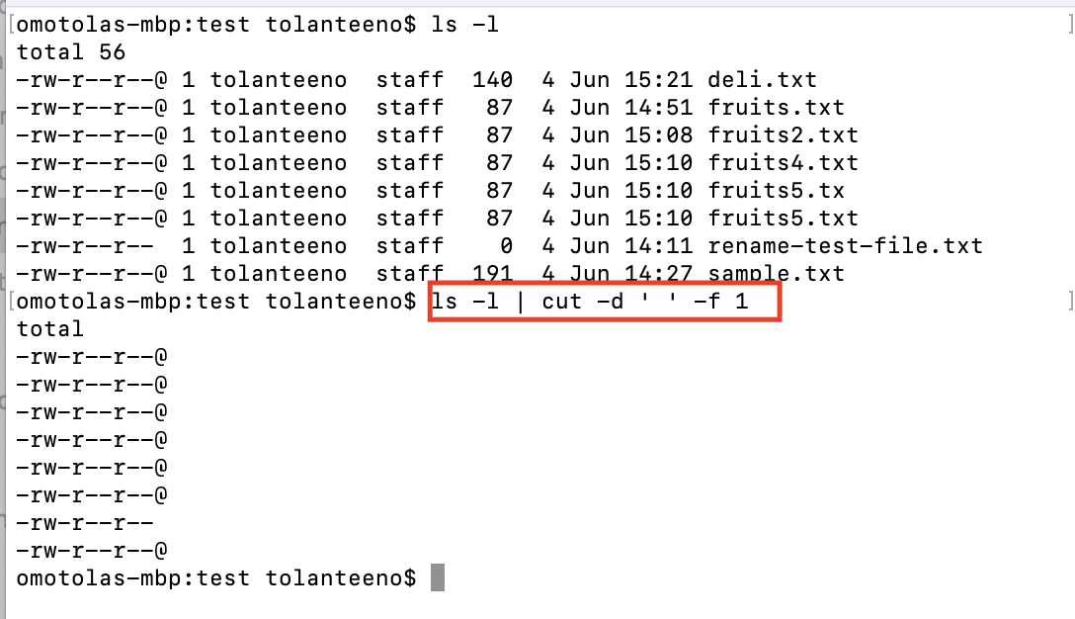

**WC Command.** This is used to count words, characters and lines in a file. The result is a 4 column display. The four columns displays the number of lines, number of words, characters and file name respectively.

The wc -l option display the number of lines

The wc -w option displays the number of words

The wc -c option displays the number of characters

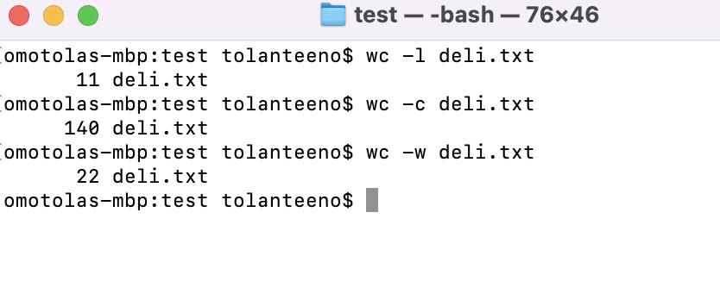

**ECHO Command**

Echo command can be used to repeat expressions, can be used to store and recall variables as well as used to find the home location as show in the snapshot below:

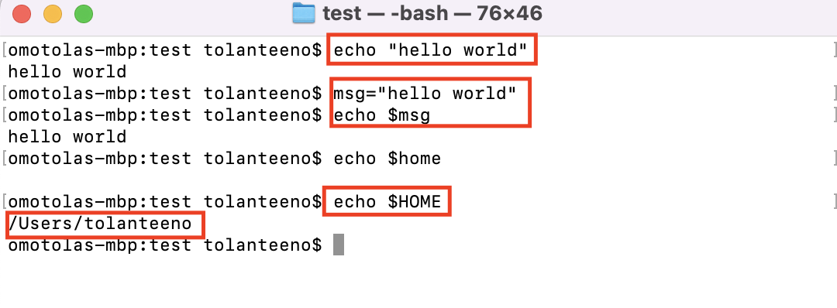

The echo command with the -e option and \n can be used to modify the output text and insert a new line. Using \t in the text can be use to insert a tab as follows:

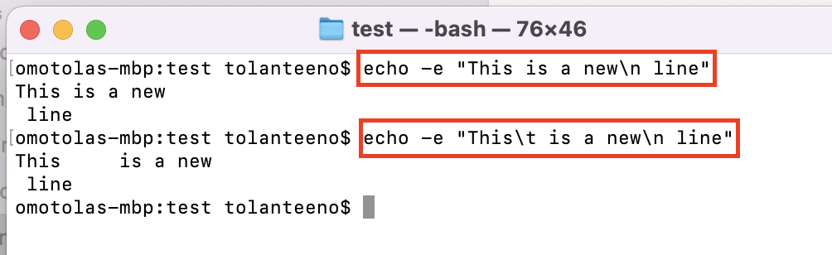

Echo can also be used to write the output of a command to a file as illustrated below:

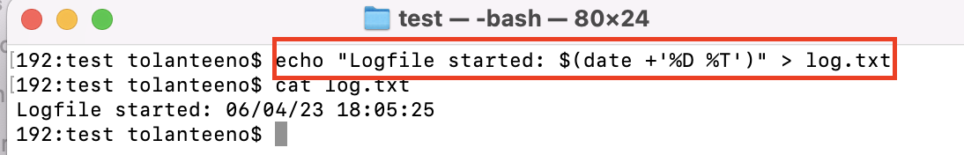

**PS Command:** This command provides a list of running processes as well as their process IDs

The ps -e command gives a list of all the processes running on the system whilst ps -T gives all the processes running on the terminal. See examples of the command below:

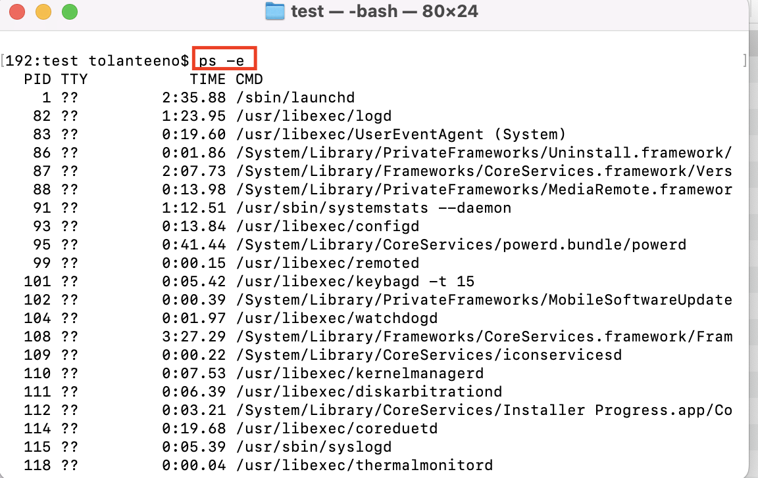

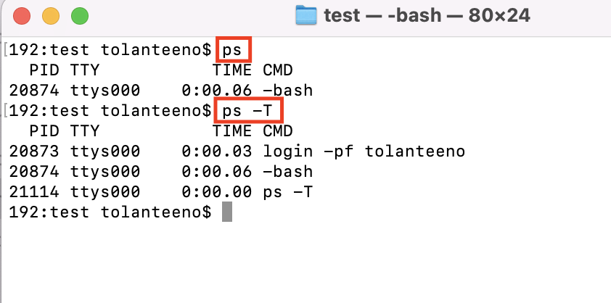

The running processes can be sent to the grep command to filter process that are running bash like below:

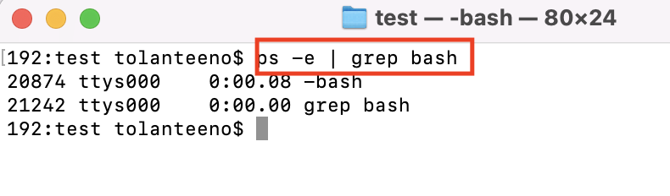

**LSOF command** - List open files. It is used to find out which files are opened by which process

Note that to list all open files properly, you should use sudo.

Using ‘lsof -u tolanteeno’ can be used to list all the files opened by the user called “tolanteeno”

